BIO

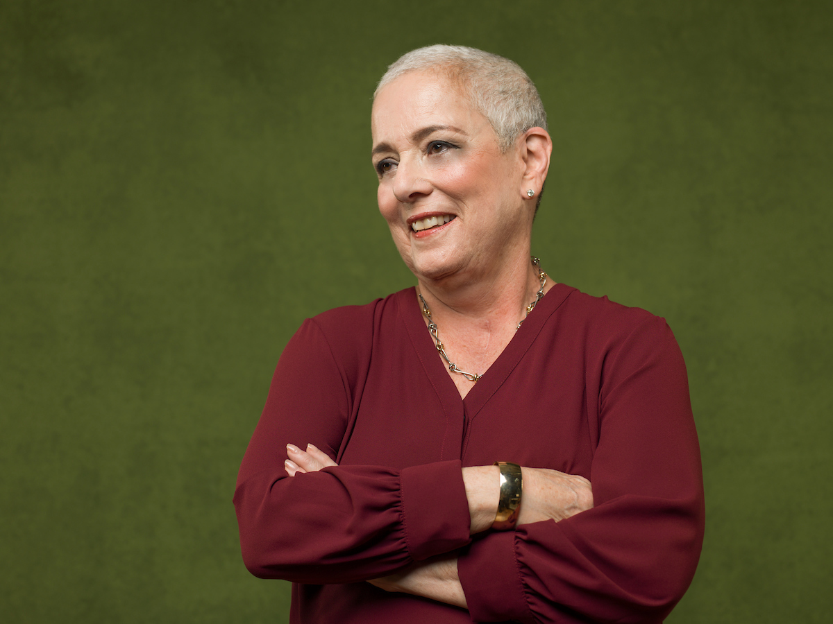

Barbara Rapaport
President, Real-time Perspectives

Barbara Rapaport passionately believes the answers are always in the room. Through her executive coaching firm, Real-time Perspectives, Barbara collaborates with clients to create the appropriate context for those answers to surface. She has distinguished herself with local, national, and global clients for her signature ability to guide them to reflect deeply on where they want to go – and to say out loud – what’s getting in their way. This has proven to be a meaningful approach for individuals, teams, and groups who are faced with having to make difficult decisions.

Before starting her consulting practice, Barbara joined Steelcase in 1984, beginning a 20-year career encompassing various leadership positions that ultimately inspired her “real-time” approach to leadership development and group problem-solving. As part of the executive team at Steelcase, she led a global culture analysis and transition strategy aimed at renewing a company in grief over nine, post-9/11 salaried workforce reductions. She assumed management positions in Talent Development, Sales Training, and Marketing Communications. She also became well-versed in helping Steelcase and Dealer design teams navigate the complexities associated with space utilization. Since then, she has used elements of the Design Thinking Framework (a.k.a. User-centered Design) in some aspects of her work with her own business clients. Prior to Steelcase, Barbara worked in Higher Education and Health Care Administration.

In her consulting practice, Barbara has worked with more than 100 varied client groups in over 20 countries. These include Fortune 500 corporations, educational and health care institutions, professional services organizations, as well as government and nonprofit agencies. She has coached senior leaders and their teams at the World Economic Forum and major public-school systems in New York, Washington D.C., Philadelphia, and Denver. She also has committed herself to helping clients uncover hidden barriers that impede their ability to embrace Diversity, Equity, and Inclusion (DEI). Most notably, she served as the Project Manager/Facilitator for Talent 2025’s ‘DEI Communities of Practice’ initiative. Over a two-year period, she convened more than thirty large and small West Michigan employers to share their DEI expertise around best practices, existing benchmarks, and future strategies.

Beginning in 2006, Barbara designed and facilitated Leadership Development Programs for the Grand Rapids Chamber – Leadership Advantage and Leading Edge. She also has provided leadership coaching to the participants in the Chamber’s Elevate Minority Business Program. In 2018, the Chamber presented her the Center for Community Leadership’s Distinguished Trustee Award. In 2017, Barbara developed a Self-Reflection Program for the Cook Academy Leadership Fellows at Grand Valley State University and a Senior Leadership Development Program for senior administrators at Ferris State University. In 2023, she was named the recipient of the West Michigan Literacy Center’s Community Engagement award.

Barbara is the author of Reimagined, a memoir recounting her harrowing experience battling and surviving a rare form of cancer. She earned her BA in American Studies at Douglass College where she was inducted into the Phi Beta Kappa Society. She holds an MS in Rehabilitation Counseling from Boston University. Barbara lives in Grand Rapids, MI with her husband Stuart. She has two wonderful grown children and is full of pride for their accomplishments.

Contact: barbara@rtperspectives.com or (616) 485-5382
www.realtimeperspectives.com

